|  |
| --- |
|  |
|  |

PROJECT – 01

Weather Report using AXIOS HTTP header

* Name : Logeshwaran c s
* Course : Full stack (MERN)
* Description : API Handling
* Front End : React JS
* Faculty Name : Gowthaman K
* Batch : 2023

(Website : [www.openweathermap.com](http://www.openweathermap.com))

* INTRODUCTION OF REACT JS
* React (also known as React.js or ReactJS) is a [free and open-source](https://en.wikipedia.org/wiki/Free_and_open-source_software) [front-end](https://en.wikipedia.org/wiki/Frontend_and_backend) [JavaScript library](https://en.wikipedia.org/wiki/JavaScript_library) for building [user interfaces](https://en.wikipedia.org/wiki/User_interface) based on [components](https://en.wikipedia.org/wiki/Component-based_software_engineering).
* It is maintained by [Meta](https://en.wikipedia.org/wiki/Meta_Platforms) (formerly Facebook) and a community of individual developers and companies.
* React can be used to develop [single-page](https://en.wikipedia.org/wiki/Single-page_application), mobile, or [server-rendered](https://en.wikipedia.org/wiki/Server-side_rendering) applications with frameworks like [Next.js](https://en.wikipedia.org/wiki/Next.js).
* Because React is only concerned with the user interface and rendering components to the [DOM](https://en.wikipedia.org/wiki/Document_Object_Model),
* React applications often rely on [libraries](https://en.wikipedia.org/wiki/JavaScript_libraries) for routing and other client-side functionality.

PROGRAM

TOOL : V S Code

APP.JS

import React, { useState } from 'react'

import axios from 'axios'

import './App.css'

function App() {

  const [data, setData] = useState({})

  const [location, setLocation] = useState('')

const url = `https://api.openweathermap.org/data/2.5/weather?q=${location}&units=imperial&appid=895284fb2d2c50a520ea537456963d9c`

  const searchLocation = (event) => {

    if (event.key === 'Enter') {

      axios.get(url).then((response) => {

        setData(response.data)

        console.log(response.data)

      })

      setLocation('')

    }

  }

return (

    <div className="app">

      <div className="search">

        <input

          value={location}

          onChange={event => setLocation(event.target.value)}

          onKeyPress={searchLocation}

          placeholder='Enter Location'

          type="text" />

      </div>

      <div className="container">

        <div className="top">

          <div className="location">

            <p>{data.name}</p>

          </div>

          <div className="temp">

            {data.main ? <h1>{data.main.temp.toFixed()}°F</h1> : null}

          </div>

          <div className="description">

            {data.weather ? <p>{data.weather[0].main}</p> : null}

          </div>

        </div>

{ data.name !== undefined &&

          <div className="bottom">

            <div className="feels">

              {data.main ? <p className='bold'>{data.main.feels_like.toFixed()}°F</p> : null}

              <p>Feels Like</p>

            </div>

            <div className="humidity">

              {data.main ? <p className='bold'>{data.main.humidity}%</p> : null}

              <p>Humidity</p>

            </div>

            <div className="wind">

              {data.wind ? <p className='bold'>{data.wind.speed.toFixed()} MPH</p> : null}

              <p>Wind Speed</p>

            </div>

          </div>

        }

      </div>

    </div>

  )

}

export default App;

APP.CSS

* {

  box-sizing: border-box;

  margin: 0;

  padding: 0;

}

p {

  font-size: 1.6rem;

}

h1 {

  font-size: 6rem;

}

.app {

  width: 100%;

  height: 100vh;

  position: relative;

  background-color: rgba(111, 103, 103, 0.2);

  color: #faf9f9;

}

.app:before {

  content: ' ';

background: url('./assets/bg1.jpg') no-repeat center center/cover;

  position: absolute;

  width: 100%;

  height: 100%;

  top: 0;

  left: 0;

  z-index: -1;

}

.app .search {

  text-align: center;

  padding: 1rem;

}

.app input {

  padding: .7rem 1.5rem;

  font-size: 1.2rem;

  border-radius: 25px;

  border: 1px solid rgba(255,255,255, 0.8);

  background: rgba(255,255,255, 0.1);

  color: #f8f3f3;

}

::placeholder {

  color: #f8f8f8;

}

.container {

  max-width: 650px;

  height: 450px;

  margin: auto;

  padding: 0 1rem;

  position: relative;

  top: 10%;

  display: flex;

  flex-direction: column;

  justify-content: space-between;

}

.app .top {

  width: 100%;

  margin: 1rem auto;

}

.app .description {

  position: relative;

  right: -85%;

  font-weight: 700;

}

.app .bottom {

  display: flex;

  justify-content: space-evenly;

  text-align: center;

  width: 100%;

  margin: 1rem auto;

  padding: 1rem;

  border-radius: 12px;

  background-color: rgba(255, 252, 252, 0.2);

}

.bold {

  font-weight: 700;

}

OUTPUT

STEP 01 -> Enter the Location and Press “ENTER”

Button.

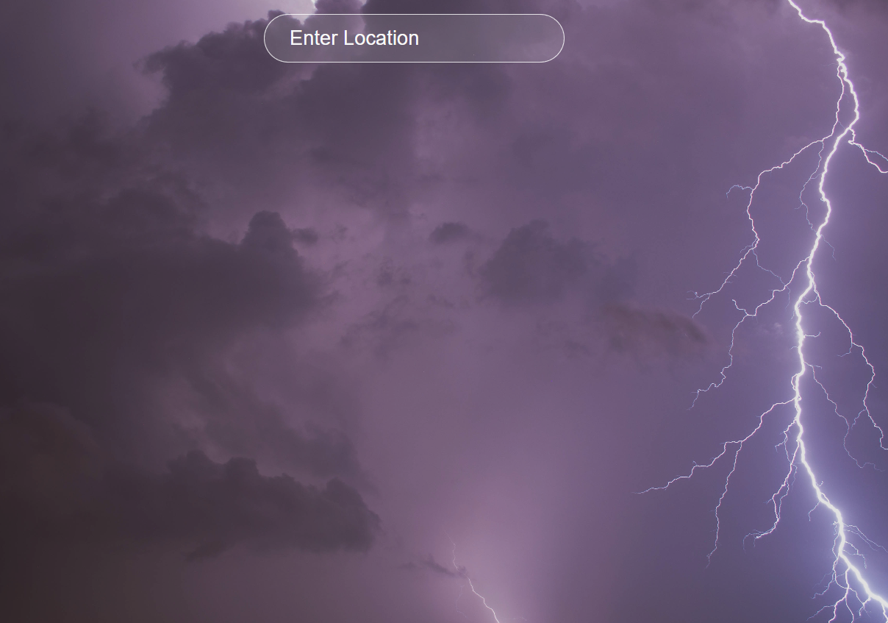

STEP 02 -> Enter “KARUR” and See the Weather

Report about the karur.

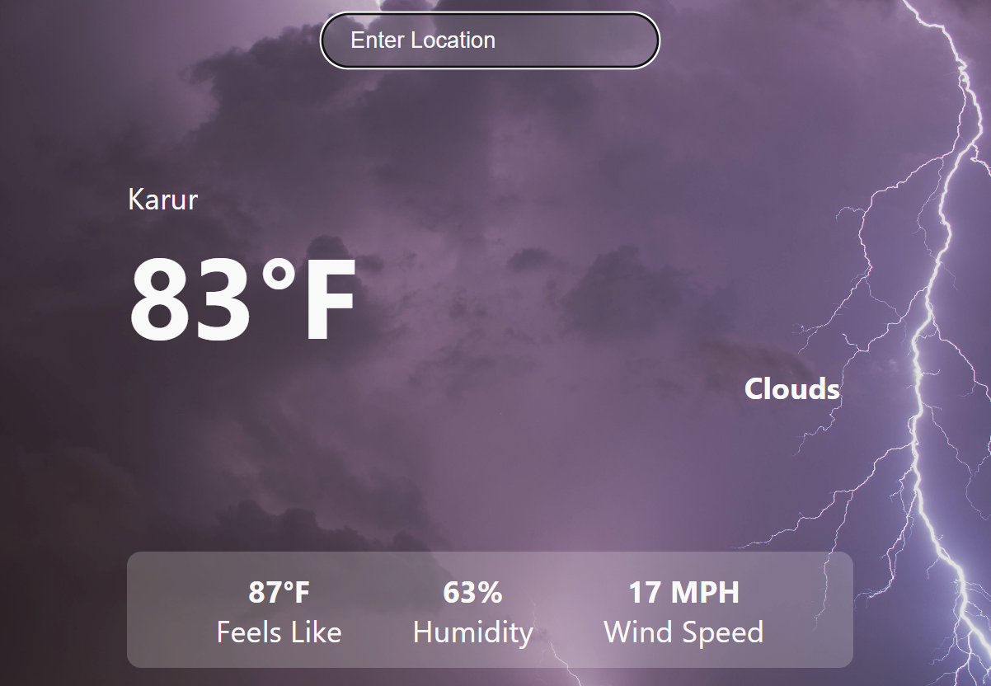

THANKING YOU